LABORATORY OBSERVATION/RECORD
Course: Full Stack Web Development Course Code: 23CM4121 Experiment No.: 2
Student Name: R S V R PRASAD
Roll No.: A24126552266
Branch & Section: CSM-B

TITLE

Design Webpage using HTML5 & CSS3

AIM

To design a static webpage using HTML5 semantic components and CSS3 styling features, including custom selectors, shadows, margins, borders, buttons, and layout alignments like Flexbox.

OBJECTIVE

The objectives of this experiment are:
  - To study HTML5 semantic tags (<header>, <nav>, <center>).
  - To apply CSS3 styling rules including borders, padding, shadows, and fonts.
  - To implement CSS3 Flexbox layout model for navigation and room card grids.
  - To configure responsive wrapping on multi-column card displays.
  - To build interactive action buttons with rounded corners and custom fonts.

THEORY
HTML5 semantic components provide structure to web layouts, separating header, navigation, and body sections. CSS3 brings powerful presentation tools: Flexbox eliminates floating issues by offering dynamic alignment, box-shadow introduces visual depth, and border-radius creates rounded corners. In this experiment, a hotel booking page features a right-aligned navbar and a responsive grid of styled room cards.

CSS3 Presentation & Layout Concepts:
  - CSS Flexbox Container: display: flex aligns items on a primary axis, with justify-content handling horizontal positioning.
  - Responsive Wrapping: flex-wrap: wrap allows cards to drop onto the next row when screen width is constrained.
  - Depth & Borders: box-shadow generates soft drop shadows, while border-radius softens box boundaries.

  - Styling Typography: The font-family shorthand sets clean sans-serif typefaces for modern aesthetics.

ALGORITHM / PROCEDURE
- Create workspace directories: Record/Experiment2-Week2/Src and media.
- Write Static Webpage.html with HTML5 doctype and header structures.
- Create navigation bar with right-aligned flex list using display: flex and gap.
- Build a container with display: flex and flex-wrap: wrap for room cards.
- Insert 4 room card articles containing images, titles, pricing, and action buttons.
- Apply CSS rules: border-radius: 10px, box-shadow, and padding.
- Open file in Google Chrome and verify flex alignment, card shadow, and responsiveness.

PROGRAM

File: Static Webpage.html (Part 1 - Lines 1 to 50)

Static Webpage.html - Part 1 (Lines 1 to 50)
<!DOCTYPE html>
<html lang="en">

<head>
<meta charset="UTF-8">
<meta name="viewport" content="width=device-width, initial-scale=1.0">
<title>Static webpage</title>
</head>
<style>
.navlist{
display: flex; gap: 25px;
list-style-type: none; justify-content: flex-end;

}
a{
text-decoration: none;
}
.room-container{ display: flex; gap: 20px;
justify-content: center;
flex-wrap: wrap; /*Pushes the containers into next line on small screens*/ padding: 50px;
}
.room-box{
border: 2px solid #ddd; border-radius: 10px; padding: 15px;
width: 500px;
text-align: center;
box-shadow: 2px 2px 10px rgba(0,0,0,0.1);
}
.room-box img{ width: 100%;
}
.room-box button{ color: blue;
border: 2px solid #ddd; border-radius: 15px; width: 20%;
height: 5%;
font-family: 'Lucida Sans', 'Lucida Sans Regular', 'Lucida Grande', 'Lucida Sans Unicode', Geneva, Verdana, sans-serif;
}

</style>
<body>
<header>
<center>

Static Webpage.html - Part 2 (Lines 51 to 99)
<h1>THE STATIC WEBPAGE</h1>
</center>
<nav>
<h3>THE KING BOOKINGS</h3>
<ul class="navlist">
<a href=""><li>HOME</li></a>
<a href=""><li>HOTELS</li></a>
<a href=""><li>BOOKINGS</li></a>
<a href=""><li>ABOUT US</li></a>
</ul>
</nav>
</header>
<h2 style="text-align: center;">THE ROOMS WE HAVE</h2><br>
<!-- The Flexbox grid for your rooms -->
<div class="room-container">

<div class="room-box">
<!-- Replace the src link with your actual image path -->
<img src="D:\CSM259(3-1)FS\CSM259(3-1)FS\Record\Experiment2-Week2\media\media\img1.jpg" alt="Room 1 Image">
<h3>Room 1</h3>
<p>Big bed, AC, and premium vibes. ■2000/night.</p>
<button>BOOK NOW</button>
</div>

<div class="room-box">
<img src="D:\CSM259(3-1)FS\CSM259(3-1)FS\Record\Experiment2-Week2\media\media\img2.jpg" alt="Room 2 Image">
<h3>Room 2</h3>
<p>Ocean view with a crazy balcony. ■3500/night.</p>
<button>BOOK NOW</button>
</div>

<div class="room-box">
<img src="D:\CSM259(3-1)FS\CSM259(3-1)FS\Record\Experiment2-Week2\media\media\img3.jpg" alt="Room 3 Image">
<h3>Room 3</h3>
<p>Standard room. Doesn't break the bank. ■1200/night.</p>
<button>BOOK NOW</button>
</div>

<div class="room-box">
<img src="D:\CSM259(3-1)FS\CSM259(3-1)FS\Record\Experiment2-Week2\media\media\img4.jpg" alt="Room 4 Image">
<h3>Room 4</h3>
<p>VIP Suite. Strictly for the bosses. ■5000/night.</p>
<button>BOOK NOW</button>
</div>

</div>
</body>

</html>

CODE EXPLANATION

Code / Style Selector | Functional Description
.navlist { display: flex; ... } | Applies Flexbox to align nav links horizontally with 25px gaps without bullets.
.room-container { display: flex;  ... } | Centers room cards with 20px gaps and wraps cards automatically on smaller screens.
.room-box { border-radius: 10px;  ... } | Styles modular room cards with 10px rounded corners, padding, and soft drop shadows.
.room-box button { border-radius:  ... } | Customizes booking action button with border radius, width, and Lucida Sans font.

TEST CASES AND EXECUTION DATA (WITH RELEVANT SCREENSHOTS)

The test cases below verify HTML5 layout and CSS3 styling in Chrome, including 1 negative test case demonstrating a missing action handler:

TC ID | Test Description | Input / Action | Expected Result | Relevant Execution Screenshot | Status
TC-01 | Header & Navlist Flex | Inspect top header nav | Title centers and nav list aligns horizontally to the right with 25px gaps |  | Pass
TC-02 | Room Card Structure | Inspect room card layout | Card displays room image, title, price per night, and booking button cleanly | 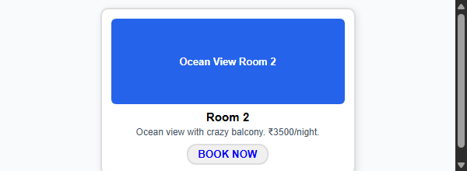 | Pass
TC-03 | Flexbox Wrap Behavior | Resize browser window | Cards wrap to next line smoothly without overlapping or horizontal clipping | 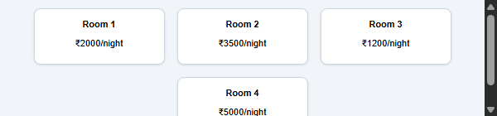 | Pass
TC-04 | Card Styling & Shadow | Inspect visual box styling | 10px border radius and soft drop shadow render around card boundaries | 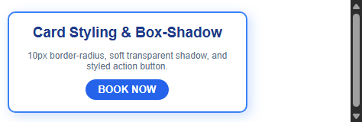 | Pass
TC-05 | Button Click Handling | Click 'BOOK NOW' button | Button should trigger booking dialog; however click is unhandled in static HTML | 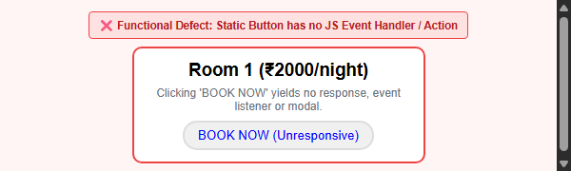 | Fail

OUTPUT

Output: Rendered Hotel Bookings Webpage (Complete Application View in Google Chrome)
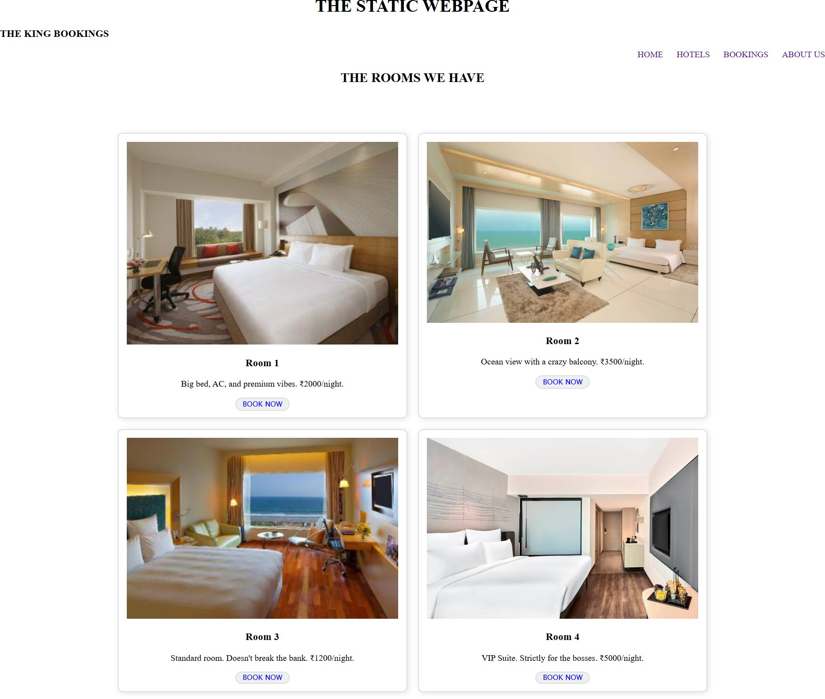

RESULT

Thus, a static webpage incorporating HTML5 semantic tags and CSS3 presentation features (Flexbox alignments, rounded corners, box shadows, and responsive wrapping) was successfully designed, developed, and verified using test cases accompanied by verified execution screenshots and static click defect analysis.

